LAB Assignment No 10
K means Clustering Schemes in Machine Learning
In this lab, students will learn and implement K-Means Clustering, an unsupervised machine learning algorithm used to group data points into K distinct clusters based on similarity. Unlike supervised learning methods, K-Means does not require labeled data. Students will first apply K-Means on a small numerical dataset to understand clustering behavior, then use it on real-world datasets to visualize cluster formation and analyze results. Model performance will be interpreted using visualization and cluster characteristics.

Introduction
K-Means Clustering is an unsupervised learning algorithm that partitions a dataset into K clusters, where each data point belongs to the cluster with the nearest mean (centroid).
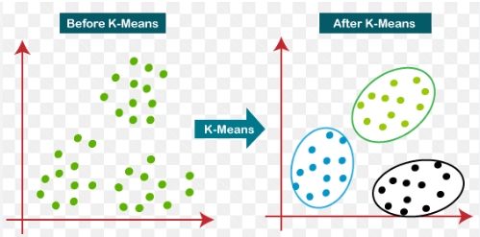
Working of K-Means:
- Select the number of clusters K
- Initialize K centroids randomly
- Assign each data point to the nearest centroid
- Update centroids by computing the mean of assigned points
- Repeat steps 3 and 4 until convergence
Key Concepts:
- Centroid – center of a cluster
- Inertia – sum of squared distances within clusters
- Elbow Method – technique to choose optimal K
Applications:
- Customer segmentation
- Image compression
- Market basket analysis
- Document clustering

Solved Examples
Example 1: K-Means Clustering on a Simple Dataset
Apply K-Means clustering to group students based on marks and attendance
Solution:
import numpy as np
import matplotlib.pyplot as plt
from sklearn.cluster import KMeans

# Sample data: Marks vs Attendance
X = np.array([
[40, 60],
[45, 65],
[70, 80],
[75, 85],
[90, 95],
[85, 90]
])
# Apply K-Means
kmeans = KMeans(n_clusters=2, random_state=42)
kmeans.fit(X)
labels = kmeans.labels_

# Plot clusters
plt.scatter(X[:,0], X[:,1], c=labels)
plt.scatter(kmeans.cluster_centers_[:,0], kmeans.cluster_centers_[:,1], marker='X')
plt.xlabel("Marks")
plt.ylabel("Attendance")
plt.title("K-Means Clustering (K=2)")
plt.show()

Explanation
The algorithm groups students into clusters based on similarity in marks and attendance.

Example 2: Choosing Optimal K Using Elbow Method
Use the Elbow Method to determine the optimal number of clusters.
Solution:
inertia = []

for k in range(1, 6):
kmeans = KMeans(n_clusters=k, random_state=42)
kmeans.fit(X)
inertia.append(kmeans.inertia_)

# Plot Elbow Curve
plt.plot(range(1,6), inertia, marker='o')
plt.xlabel("Number of Clusters (K)")
plt.ylabel("Inertia")
plt.title("Elbow Method")
plt.show()

Explanation
The “elbow point” in the graph suggests the best value of K where further increase does not significantly reduce inertia.

Example 3: K-Means Clustering on Iris Dataset
Apply K-Means clustering to the Iris dataset and visualize the clusters.
Solution:
from sklearn.datasets import load_iris

# Load Iris dataset
iris = load_iris()
X = iris.data[:, :2] # Use first two features for visualization

# Apply K-Means
kmeans = KMeans(n_clusters=3, random_state=42)
labels = kmeans.fit_predict(X)

# Visualize clusters
plt.scatter(X[:,0], X[:,1], c=labels)
plt.scatter(kmeans.cluster_centers_[:,0], kmeans.cluster_centers_[:,1],
marker='X')
plt.xlabel("Sepal Length")
plt.ylabel("Sepal Width")
plt.title("K-Means Clustering on Iris Dataset")
plt.show()

Explanation
K-Means successfully groups data into three clusters corresponding to Iris species.

Lab Assignment No. 10

Question 1
Write Python code to implement K-Means clustering from scratch using the following data points:
P1(1,3), P2(2,2), P3(5,8), P4(8,5), P5(3,9),
P6(10,7), P7(3,3), P8(9,4), P9(3,7)

Tasks:
- Use K = 3 clusters
- Initialize centroids as
  - C1 = P7(3,3)
  - C2 = P9(3,7)
  - C3 = P8(9,4)
- Perform 2 iterations manually in code
- Plot all points and centroids
- Label all points (P1…P9)
- Sketch the clusters using matplot library in python
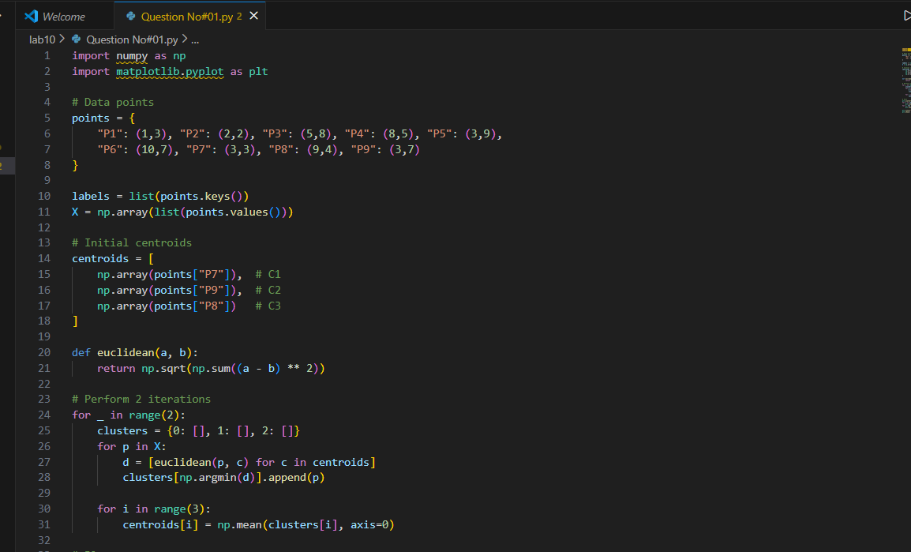
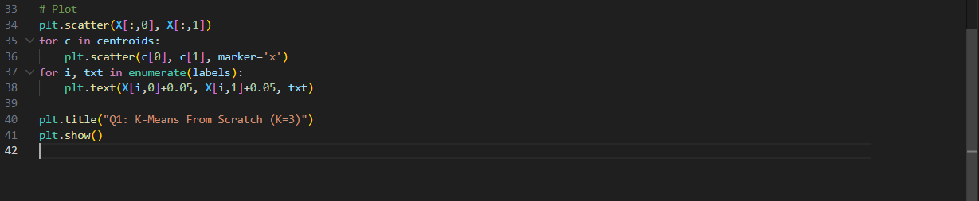

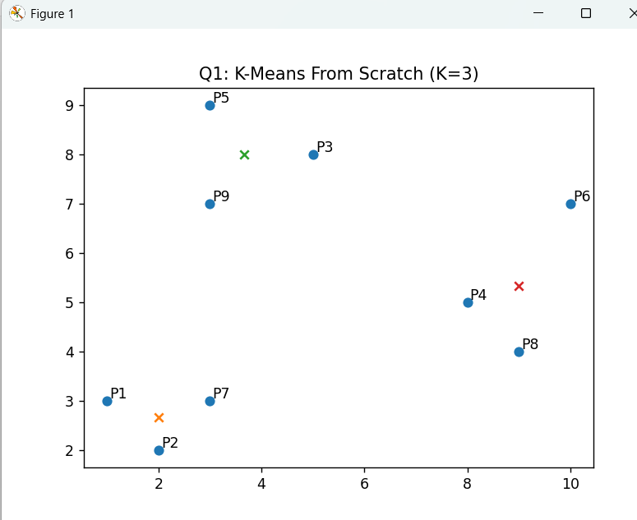
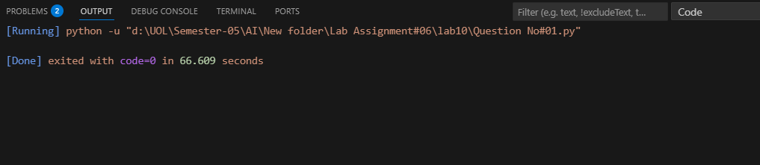
Question No. 2
Use the scikit-learn KMeans() library to cluster the same points.
P1(1,3), P2(2,2), P3(5,8), P4(8,5), P5(3,9), P6(10,7), P7(3,3), P8(9,4), P9(3,7)
Tasks:
- Use K = 2, 3, and 4
- Plot the clustering result for each K
- Compare:
  - Number of points in each cluster
  - Final centroid locations
- Draw the 3 graphs in your lab copy and explain how the shapes change with K.
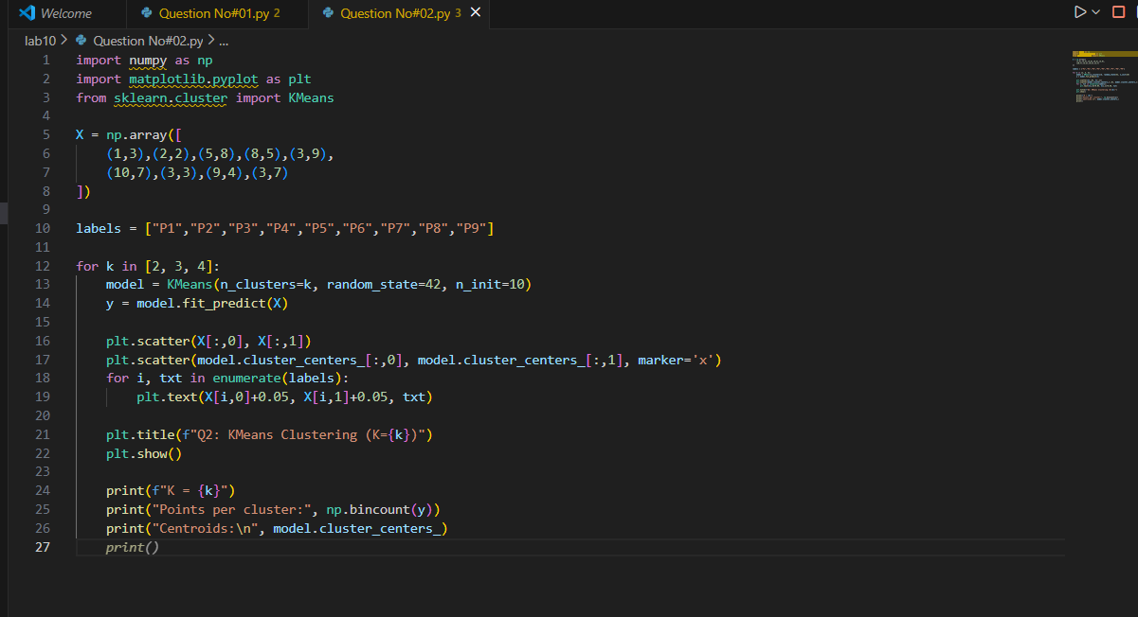
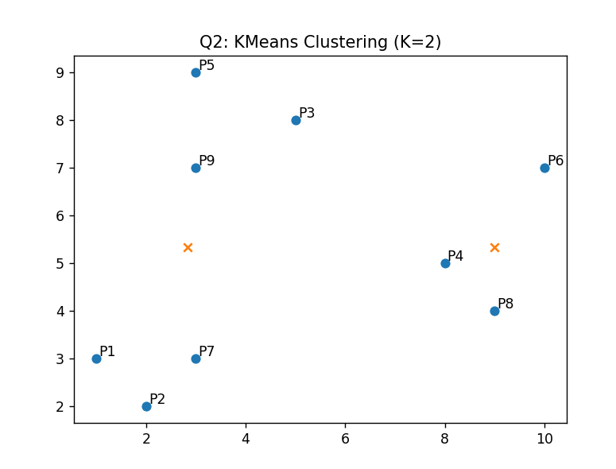
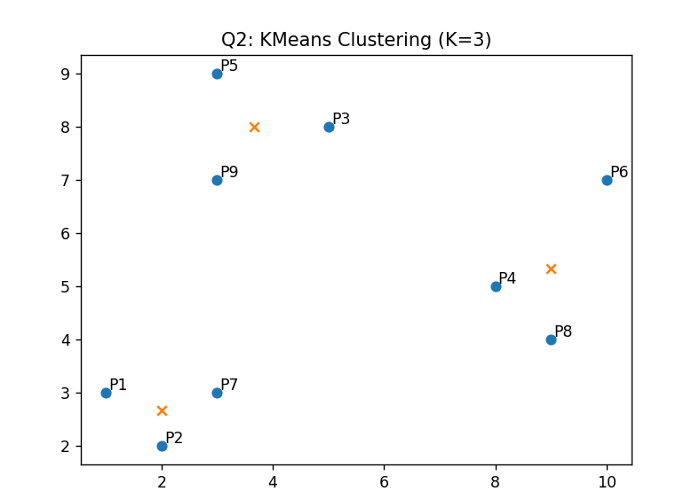
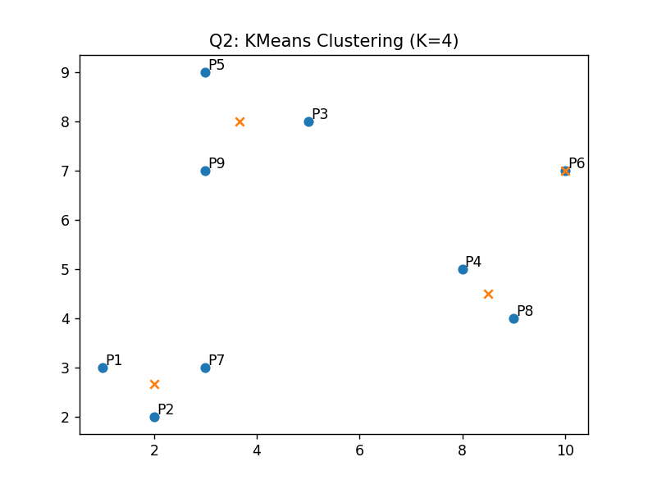
Output:
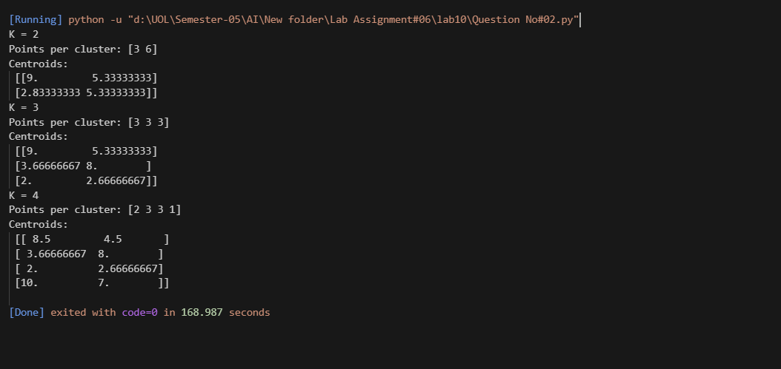

Question 3 — Add a New User Point and Re-Cluster
Given the original 9 points, add a new user: P10(6,2)
Tasks:
- Run K-Means using K = 3
- Plot the graph with all 10 points
- Identify:
- Which cluster P10 joins
- How centroids shift after adding P10
- Sketch before/after clusters in notebook
- Write a short explanation about how a new data point affects clustering.
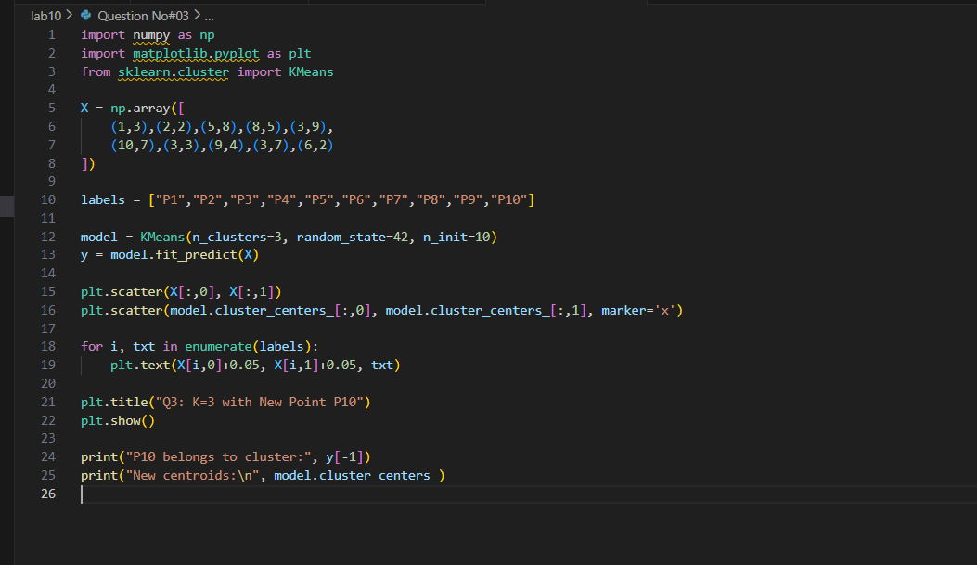
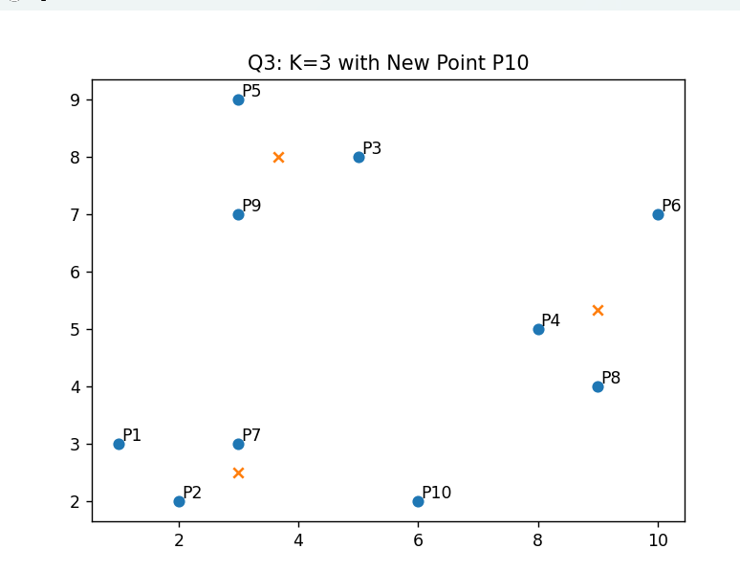
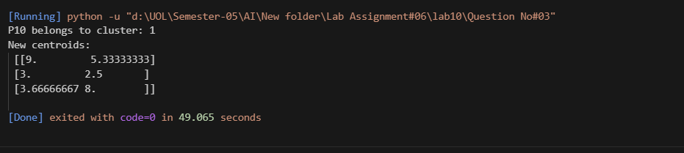

Question 4 — Distance Table + First Iteration Manually
Using the given 9 points and initial centroids:
C1(3,3), C2(3,7), C3(9,4)

Tasks:
- Compute Euclidean distance of each point to each centroid (manually or in python)
- Create a distance table:
Point | Dist to C1 | Dist to C2 | Dist to C3 | Assigned Cluster
- Perform only the first iteration
- Compute new centroids
- Plot the first-iteration graph
- Draw the graph in your copy and show all labels.
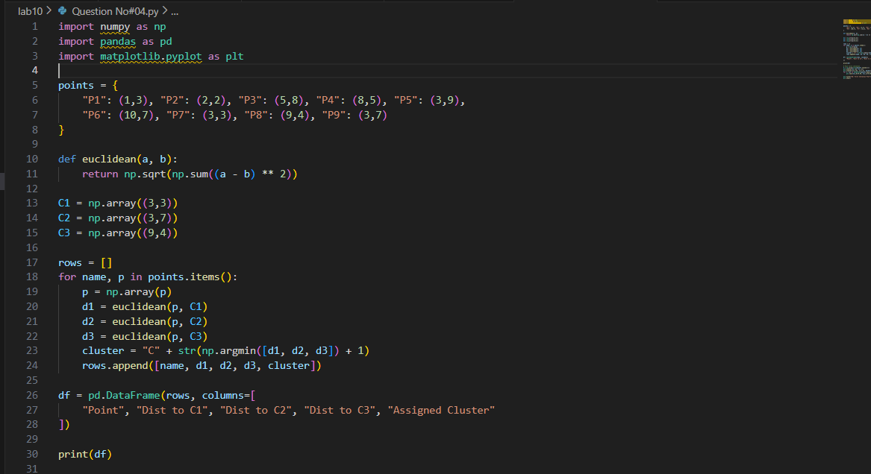
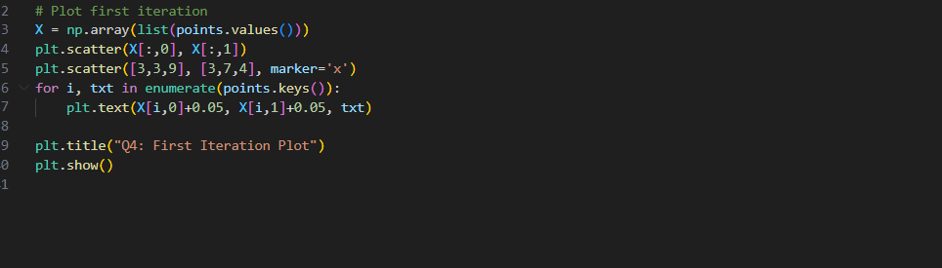

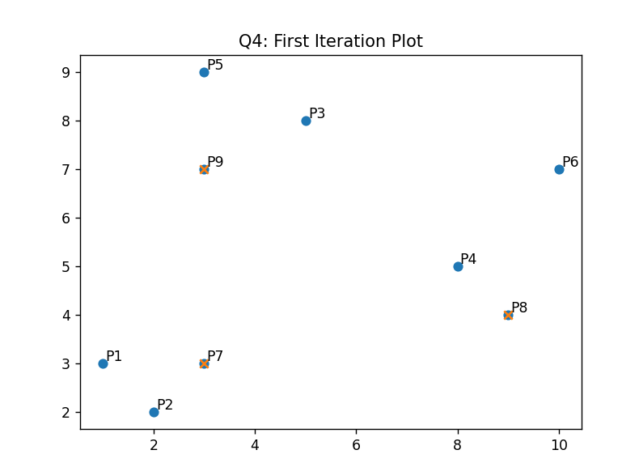
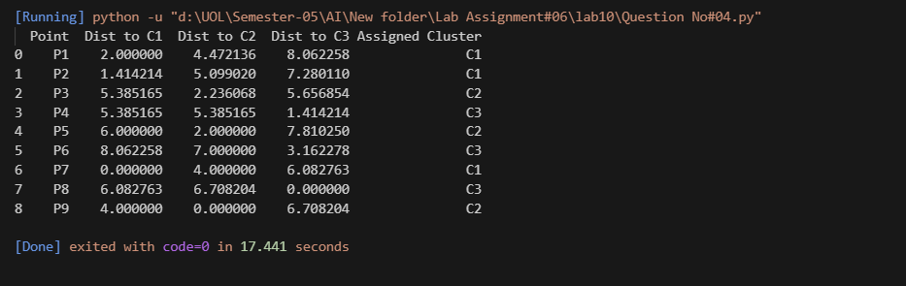

LAB Assessment

Student Name |  | LAB Rubrics | CLO3 , P5, PLO5
Student Name |  | Total Marks | 10
Registration No |  | Obtained Marks
Registration No |  | Teacher Name | Dr. Syed M Hamedoon
Date |  | Signature

